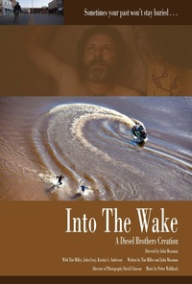

INTO THE WAKE OVERVIEW

Press Contact:
David Cooper, MVP Public Relations, LLC
(917) 716-8566 / david@mvppr.com

LATEST NEWS

ACTION THRILLER INTO THE WAKE OPENING FEATURE AT
SAN ANTONIO FILM FESTIVAL JUNE 20 – Into The Wake, a dark and powerful award-winning psychological thriller will open the San Antonio Film Festival on Wednesday, June 20 at 7p.m. (CT) at Santikos Rialto Theater.
INTO THE WAKE TO PREMIERE AT CHICAGO’S RENOWNED GENE SISKEL FILM CENTER IN JULY – Into The Wake, a dark and powerful award-winning psychological thriller will have its Chicago premiere with screenings July 21, 23, and 25 at the renowned Gene Siskel Film Center.

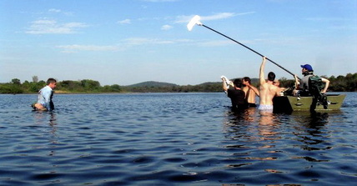

WHAT THEY’RE SAYING ABOUT INTO THE WAKE

"Winter's Bone--with more action" – Wisconsin State Journal

"Into the Wake is a smart impressionistic mystery-cum-thriller… an impressive directorial debut …” – Tonight At The Movies

“Into the Wake … a film worth checking out should it hit a festival near you.” – Tonight At The Movies

“Mossman and co-writer Tim Miller… a sharp instinct for thriller storytelling…” – Dane101

“Mossman and Miller… start by setting a friendly and humane tone, then work their way to the story's heart with a lean and cruel determination.” – Dane101

“…Unfolds capably and it builds to a powerful finale. It's what film festivals are for.” – Phoenix Film Festival

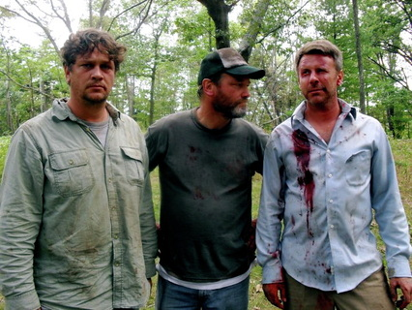

Synopsis
Exploring themes of abandonment, revenge and the cyclical nature of violence, Into The Wake is a dark and powerful psychological action thriller. Directed by John Mossman and starring Tim Miller, Into The Wake follows the character of Kyle, who is lured from the city of Chicago to the remote riverbanks of his youth in Wisconsin by a cryptic phone call. Caught in a violent clan war that he ran from years before, his life unravels rapidly as he descends further into his past – when he witnessed a murder as a child.

Color / Canon 5d Mark II
2:35 Scope
Running Time: 77 minutes

Screening History
Phoenix Film Festival Mar 30, 31, Apr 1, 2012 - Festival Premiere
Wisconsin Film Festival Apr 21 - Midwest Premiere (Golden Badger Award)
Tupelo Film Festival May 19 – Southeast Premiere (Best of Fest Award)
Lighthouse Film Festival June 2 – Northeast Premiere (Special Jury Award)
Dances With Films June 4 – West Coast Premiere (Industry Choice Award)
San Antonio Film Festival June 20 – Selected Opening Night Feature
Al Ringling Theatre June 29 – July 1 – Baraboo Premiere
Gene Siskel Film Center July 21, 23, 25 – Chicago Premiere

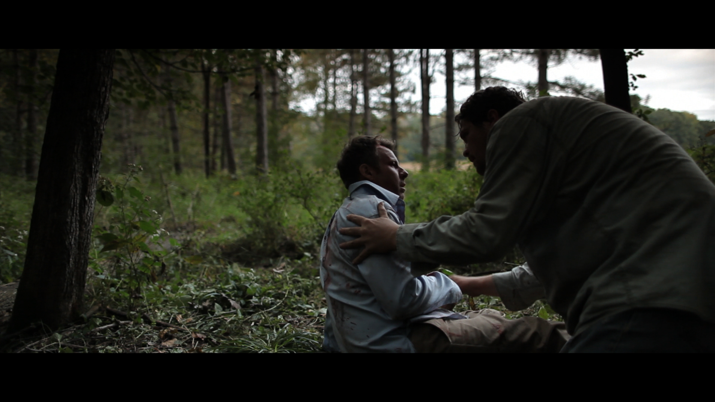

BACKGROUND NOTES

- Co-written and produced by Mossman and Miller, Into The Wake was filmed in Bridgeport truck yards on Chicago’s South Side and along the river country and towering bluffs of southwestern Wisconsin. Into The Wake was a truly remarkable collaboration of passionate filmmakers that captured this story with high cinematic quality and solid acting by the efforts of a small crew, 35 actors and a miniscule budget for a film of this scope and genre.

- Praised by critics as “‘Winter’s Bone’ – with more action” and a “smart impressionistic mystery-cum-thriller,” Into The Wake is one of the surprise hits of the 2012 film festival circuit, receiving critical acclaim across the country including during its world premiere at the Phoenix Film Festival and winning top awards at festivals in Wisconsin, New Jersey, Mississippi and Hollywood, where it earned the coveted “Industry Choice Award” at the Dances With Films Festival.

- The making of Into The Wake is as captivating as the action on screen. In late-night hours between day jobs and raising kids, Mossman and Miller wrote the screenplay. Most of the Chicago interiors took place in an empty, foreclosed building and, during the shooting, the cast and crew endured brutal heat and humidity. As production moved to Wisconsin, the team could not have anticipated the challenges it would encounter in the wilderness, including near-death incidents, roaring river currents, insect infestations and much more.

KEY QUOTES

“I’ve had a long fascination with characters that struggle with their acts, or swim upstream against a past that has been forced upon them. In this river journey Into The Wake there is something inevitable and comforting about a character that faces a violent test and submits to a resolution that has its own peaceful beauty.” -- John Mossman

"John and I had control of the story, but zero control of time. Unless it was a really bad injury we'd just roll. I worked out for months doing heavy plyometric training. But running and swimming full speed dressed in business casual was fairly high on the stupid meter." -- Tim Miller

Director Biography

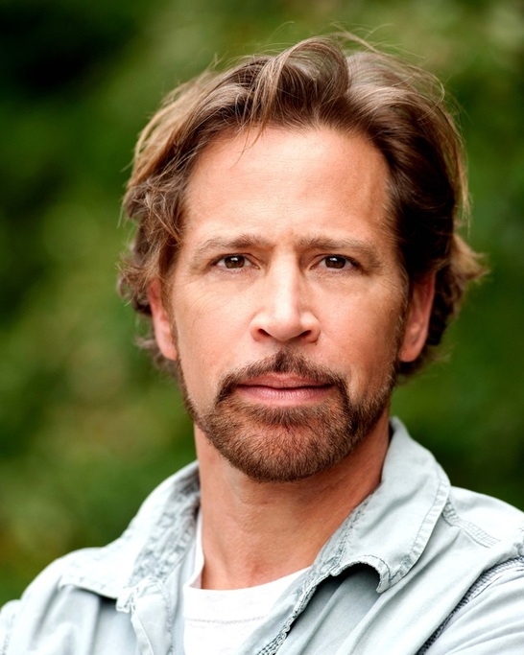

John Mossman, Director, Producer, Co-Writer, Editor

John Mossman has written, produced and directed numerous award-winning short films, documentaries and videos. He is the 2002 recipient of the "Best Director" Award from the Midwest Independent Film Festival for his work on the short film Jell-Ohh Lady, which also screened at the Los Angeles DGA and Egyptian Theater as part of the American Cinematheque Series, and the Palm Springs International Short Film Festival where it won Audience Favorite. His previous short Draggage was awarded a Lagniappe Award at The New Orleans Film Festival, Best of Fest at the 40th Annual Rochester Film Festival, and was judged "best no budget film of the year" at the Palm Springs Film Fest. Spaceman Dan’s 243rd Flight has screened at numerous international fests, where it has received Best of Fest, Audience Favorite and a Kodak Opportunity Award. He has won two Telly Awards as a director, most recently for There's No Such Thing As Crazy, also winner of a 2005 Voice Award. As coordinator of the IFP-Chicago mentorship program he has overseen the production of numerous short films, two of which have won national Emmy Awards in the High School Television category. He is co-founder and associate director of The Artistic Home, a theater and training program for actors and directors in Chicago, where he has directed the acclaimed revivals of Juno and the Paycock, Look Homeward, Angel, Natural Affection and Clash By Night, among others. He has performed at numerous theaters around the country and is an acting instructor at The Artistic Home.
As an actor he has appeared in numerous theaters throughout the United States, as well as in film and on television. He was nominated for an Equity Jeff Award for his performance in Peer Gynt, which also won him the Chicago Stage Talk Award for Best Performance by an Actor. He most recently performed the title role in Macbeth, and will be appearing in The March at Steppenwolf Theater in spring 2012. He currently teaches directing at Columbia College, where he also supervises the Independent Projects in Narrative Film program. He has served on the boards of IFP – Chicago and The Artistic Home Theater. He attended the University of Wisconsin-Madison where he received degrees in Film and Theater. More about John can be found at www.mossmanfilms.com

KEY CREW BIOGRAPHIES

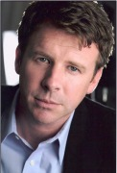

Tim Miller, Producer, Co-Writer, Lead Actor

Tim has worked as an actor, screenwriter, director and theater producer in Chicago, New York and Los Angeles. Prior to shooting Into The Wake he was last seen onscreen on the New York-based feature The Immaculate Misconception. Other past Film/TV work includes his collaborations with John Mossman on the award-winning short films Draggage and Jell-ohh Lady as a lead actor, screenwriter and composer, Unsolved Mysteries, Fight The Power, To The Moon and Changing Man. On stage, past credits include off-off Broadway at the Ohio Theater on Testimony with Israeli troupe LeeSaar, Soft Target and Jeff Award Winner Only The Sound (Chicago Dramatists), A Soldier’s Play and King Of Coons (directed by Harry Lennix) (Congo Square Theatre Ensemble), multiple Jeff winner Rosemary (Prop Thtr) in role of John F. Kennedy, Pentecost (Irish Repertory) at Victory Gardens, Butley, Brilliant Traces, The Years, The Rose Tattoo, and The Dining (Center Theater Ensemble), Clash By Night, Angel City, Days To Come and Into The Boom Boom Room (The Artistic Home). Between 1992 and 1995, Tim was a regular onstage with house team The Lost Yetis at I.O., the former ImprovOlympic, under the tutelage of both the late Del Close and writer/director Adam McKay. As a theater producer, he helped guide a string of consecutive plays receiving critical acclaim for the Chicago theater ensemble The Artistic Home: Modigliani, Look Homeward, Angel and Juno and the Paycock which garnered a Jeff Award. In 2009 he directed the U.S. premiere of David Eldridge’s Incomplete And Random Acts Of Kindness. Past written work produced includes the short film Jell-ohh Lady, Choices, a Telly Award-nominated narrative on drug-awareness, and a Chicago production of his one-act play 8-Point. He is a graduate of Purdue University.

David Clawson, Director Of Photography
David has served as Cinematographer on Into The Wake, feature documentary Ten Mountains Ten Years, and on the television series American Loggers, Hillbilly Handfishin’, Knights of Mayhem, Tattoo Wars, Dancing Tweens, The Fairway Gourmet and Female Forces. He is currently shooting a project for National Geographic in Afghanistan May-June 2012 about the Air Force’s Emergency Extraction Team.

Petter Wahlbäck, Composer
Petter is a Swedish composer who has composed music for several award-winning films of various length and subject matter. Petter began his music career after graduating from Columbia College in 2000, and has since collaborated with Chicago filmmakers as well continued to play and record as a guitarist with several bands throughout the years. In 2008, Petter completed his MFA in film scoring at Columbia, where he currently works on staff as a music teacher.

PRINCIPAL CAST BIOGRAPHIES

Tim Miller (Kyle)
(see key crew)

Kristin Anderson (Simone)
Kristin Anderson holds a BFA in Acting from Columbia College Chicago where she starred in such play productions as Curse of the Starving Class, The Rose Tattoo, and The Violet Hour. On film, she appeared in the feature Beneath the Horizon (Kilo Productions) and Stiletto. Kristin was last seen on the stage in The Artistic Home's production of Skin of Our Teeth.

John Gray (Angus)
John is a Michigan native who came to Chicago in 1993 and has been consistently working in film, theatre, commercial, voice over, and parenthood related activities. Film credits include Hatred of a Minute (Mike Kallio dir./Bruce Campbell Prod.), Chicago Theatre credits include Penelope and Superior Donuts with Steppenwolf Theatre, along with work at Red Orchid, Mary Arrchie, Noble Fool, Shattered Globe, Famous Door and Timeline. John is a company member with the world famous Trap Door Theatre in Chicago where he has performed with dozens of productions in Chicago, across the U.S. and Romania.

KEY SUPPORTING CAST BIOGRAPHIES

Joshua Gibbons (Nick Campbell)
Josh Gibbons has performed in a variety of plays, television shows, and independent films. Credits include "The Nostradamus Effect", "Prison Break", "Welcome Back to the Barrio", and "I'm a Female...Seeking a Male" in which he played six different roles.

Helen Manassas (Tiny Campbell)
Helen is an actor, writer and musician in Chicago. Notable performances are Lady Macbeth, with Minneapolis’ Candid Theatre and the Anima of Richard III with Theo Ubique. She is a graduate of the University of IL at Chicago.

Kathy Scambiatterra (Gerri)
Kathy Scambiatterra has performed at numerous theaters, including Chicago Shakespeare Theater, the Goodman, The Artistic Home, Center Theater, Wisdom Bridge, Pegasus Players, and in Los Angeles at the Pacific Resident Theater Ensemble. She has received numerous Jeff Nominations as an actress, and has appeared in the short films The Appointment, Draggage. Ms. Scambiatterra is a graduate of the University of Illinois and is the Artistic Director of The Artistic Home where she also heads the on-going actor training program.

Rosario Vargas (Carmelina)
Rosario in a native of Columbia and has appeared on independent films in the U.S., television programs in Columbia, as well as acted and directed theater productions in Chicago, Mexico and Peru. She is the current Artistic Director of Aguijόn Theater in Chicago.

Elizabeth Laidlaw (Claudia)
Elizabeth has worked as an actor, producer and director in Chicago and nationally for 17 years. She has appeared at Writer's Theatre, Chicago Dramatists, Court Theatre, Chicago Shakespeare Theatre, The Next, About Face, Steppenwolf, The Goodman, Strawdog Theatre and many others. Recent film credits include the award-winning independent features, Dimension and Eastern College. She founded Lakeside Shakespeare Theatre in 2003 and serves as artistic director.

FULL CAST & CREW

Directed by
John Mossman

Writers
Tim Miller Co-writer
Tim Miller Story
John Mossman Co-writer
John Mossman Story

Producers
Tim Miller ... producer
John Mossman ... producer
Amy Rising ... producer
Daniel John Harris ... associate producer
Mike Mossman... associate producer
Jack Higgins... associate producer

Cast
Tim Miller ... Ken / Kyle
Kristin Anderson ... Simone
John F. Gray ... Angus

Eustace Allen ... Phoenix Man (voice)
Eric Ambriz ... Big Yard Kid
Kristin Collins ... Jogger
Michael Denini ... Monty Dinkel
Matt Dreier ... Randy Campbell
Ron Gentile ... Drum Painter
Joshua Gibbons ... Nick Campbell
Jack Higgins ... Truck Driver
James Keip ... Campbell
John LaFlamboy ... Perry McMillian
Elizabeth Laidlaw ... Claudia
Carolyn Lingeman ... Patrice
Helen Manasses ... Tiny Campbell
Joan McGrath ... Sister
Greg McNamer ... Vince Campbell
Nolan Miller ... Campbell Boy
John Mossman ... Camper #1
Mike Mossman ... McMillan Man #1
Rob Nelson ... McMillan Man #2
Kelly Owens ... Rose (voice)
Donovan Sanchez ... Small Yard Kid
Oscar Sanchez ... Yard Kid
Kathy Scambiatterra ... Gerry
Alistair Sewell ... Young Kyle
Jose Angel Torres ... Yard Kid Leader
Rosario Vargas ... Carmelina
John Waelti Jr. ... Paul Campbell
John Waelti ... Old Man Campbell
Phil Wasik ... Simone's Dad
Sam White ... Red Campbell

Original Music
Petter Wahlback

Cinematographer
David Clawson

Editor
John Mossman

Costume Design
Vanessa Luna

Make Up Department
Frances Auld ... makeup artist
Emily Mashak... assistant makeup artist

Production Manager
Jeffery Sewing ... unit production manager

Second Unit Directors or Assistant Directors
Daniel John Harris ... assistant director
Joshua Schilling ... second assistant director

Art Department
Kevin Grimon ... property master
Kevin Grimon ... set designer
Miguel Lepe ... swing gang

Sound Department
Patrick J. Bresnahan ... sound mixer (Wisconsin)
Jimmy Dixon ... sound editor
Andrew Hoppe ... boom operator
James Murray ... sound mixer (Chicago)

Camera and Electrical Department
Thomas Aylward ... grip
Christopher Lane ... assistant camera
Miguel Lepe ... grip
Chris Murphy ... gaffer

Casting Department
Miguel Lepe ... casting assistant

Transportation Department
Thomas Aylward ... production driver

Miscellaneous Crew
Thomas Aylward ... production assistant
Suzie Sinkiewicz ... production assistant
Carla Jean Greve... production assistant
Steven Anthony Greve... production assistant
Maria Michaela Griffin... production assistant
Matthew James Griffin... production assistant
Brian Hollendyke... production assistant
Nenad Jakovljevic... production assistant
Brian Kerr... production assistant
George Koeller... production assistant
Kevin Pitts... production assistant
Fatou Samba... production assistant
Amy Mossman-Schmidt... production assistant
Amanda M. Schultz... production assistant
Brandy Renee Storandt... production assistant

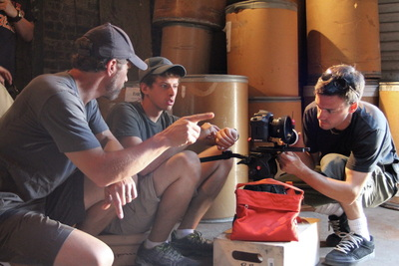

STORY BEHIND THE MAKING OF THE FILM

DIY over two cans of Pabst
Into The Wake was hatched in the summer of 2009, as John Mossman and Tim Miller decided to create a feature-length script based on a few core elements from an award-winning black-and-white short film the two collaborated on in the desert outside Palmdale, CA in 1997 with only $800, no sound package and an Elmo Super 8 camera. It was the spirit of this film titled Draggage that they longed to find again – a highly visual story with limited dialogue, limited interior shooting, and the freedom and improvisation that came along with once again having total creative control. The goal was to be shooting the script exactly a year from that evening meeting over beers in August - no matter how much money they raised.

Diapers, keystrokes and a library card
In the late night hours between their day jobs and raising kids, they put together a solid draft of the screenplay. With no attorney until a final review as a freebie, they did hours of research courtesy of the Chicago Public Library and a handful of boilerplate docs. As a result they created an LP and LLC for Diesel Brothers Films, PPM, filed their own private offering with the SEC and got their script out to potential investors. An investment of $53,000 in shares was raised by the first day of principle photography.

Testing cameras and places not to drown
David Clawson was hired as cinematographer and testing was done with the Canon 5d Mark II rigged on a steady-cam to ensure that chase sequences with Dave running after action on foot and in the water would be able to stay in focus and provide the right look. The footage looked great, no other cameras were tested. Next challenge - the river.

A big part of the action written into the script from the beginning was to take place on the Wisconsin River near the 300 ft high Ferry Bluff. Ensuring the safety of the actors swimming in full clothing on a swift current in a river known to take a few lives every year was a big concern. John and his brother Mike Mossman tested the current in several different spots during May 2010. They found an area near Mazomanie Bottoms that provided both shallow areas with stability to stand and deep cuts of water that were strong enough to pull a body away in the current.

Casting the trio
Tim was cast as Kyle from the beginning as the short-hand developed between John and Tim on previous films and screenplays together would be needed to knock out this story in 18-20 days. In addition, the physical abuse that the character of Kyle goes through in the story, in a gritty environment without any luxuries of a regular film set, seemed like a risky proposition to trust in someone else’s hands. A bad attitude after getting fed up with a few days of water, mud and bugs, as well as a lack of physical conditioning, could easily slow production and kill momentum. So Tim started hitting the weights and growing a beard.

Several Chicago actresses read for Simone and the role was cast about six weeks before Day 1 of shooting. Three days before shooting, the production lost their female lead. There was a family emergency that forced her to fly home and the decision was made
not to rely on her, or put pressure on her to return in time. It turned out to be one of the luckiest moments of the journey, as Kristin Anderson, who was unavailable for earlier auditions, arrived and brought a terrific presence to the role. After only two rehearsals for a few hours over a couple nights she was shot out of a cannon and onto the set.

Even after the river tests, the role of Angus was going to be played by John. With concerns about roughing the elements and dealing with the river, Tim and John agreed that hiring another actor wasn’t worth the risk. One early conversation ended in agreement that if they each played a brother role they wouldn’t get sued if one of them got hurt or drowned. However, they knew it was also a dangerous proposition to have John in front of and behind the camera with little time and money available. So auditions were held and John Gray auditioned. He brought an easy chemistry with Tim and a background needed to grind it out in the water and woods. Once he mentioned that he swam for four years on the high school team the search for Angus was over.

No running water, no license and no-shows? No problem.
The first week of shooting started on August 29, 2012 and was primarily on the south side truck yards of Bridgeport. There was no chance to ease into the shoot. Chicago scenes had to be captured in six days. In addition, this would be the only chance to get it right. Kyle gets his beard shaved off and hair cut short when he takes a new job in the story. There would be no opportunity for pick up shots. The production had access to a steel drum reconditioning plant for two days at no cost. But they had to juggle and split factory scenes at the start and end of the week - one day with beard, one day no beard.

There was some anxiety on the first day as two teenagers cast as kids fighting in truck yard were no-shows. The youngest boy in the scene was dropped off by his brother and John grabbed him before he left the set. He obliged, thankfully, and the day continued.
Most Chicago interiors took place at an empty, foreclosed bungalow that doubled as Simone and Kyle's home and Carmelina's apartment. The cast and crew proved very committed during brutal heat and humidity at the location, as it only had electricity for the gear. No air-conditioning, no running water, no toilet for two days of shooting.

The home was also near a busy boulevard and a mid-day flight pattern above. So the sound team simply could not shoot without shutting all of the doors and windows, even though it was over 90 degrees and humid outdoors. Towels were put under the boom operator so the microphone wouldn’t pick up his sweat dripping onto the floor. It was a challenge that forced an extreme focus among all involved, especially the actors.

In between scenes at the house and at the factory, Tim learned to ride the 1983 Honda Goldwing. He had limited riding experience in high school on a 250cc motocross bike. Now, he was riding a 1200cc motorcycle in the city and country highways with no helmet or motorcycle license. This information was withheld from his wife. Bike scenes at the payphone by the plant also happened to be only a few blocks away from a police station. Just prior to one take, a squad car rolled up and asked Tim if he was shooting a commercial and asked Tim if he was going to “pull a wheelie.” He told them no and they drove off. Tim received no citations during the shoot. However, John, a life-long cyclist, received a speeding ticket riding the same motorcycle on the first day up in Wisconsin.

Iconic shot captured
The capture of Kyle on the river was the most daunting scene of the shoot and proved to be one of the greatest successes in execution. From the storyboards with exact boat swirl of water, to the hours planned to shoot, it was as precise as a military operation. When viewing the final product on screen it is was an impressive feat in terms of production value - a tiny budget, on limited time, with no cell reception, and shooting on notoriously unpredictable and relatively wild river for only 2 half-day shoots.

3 shirts and no one on book
It was pure luck that there weren’t more continuity errors as it was an assignment passed around and often unavailable as all hand were on deck with other jobs to do. Make-up artist Franc Auld re-created blood and bruises each day through only the view finder of a camera that snapped a couple stills early on and proved nearly flawless matching Tim’s face to his varying levels of ass kicking that were shot completely out of order. Production could only afford three shirts. They were each distressed and carried very specific markings and wounds that were rotated. That task in itself took time every day, and got harder as the shoot progressed, as more distress had to be added to each shirt in the rotation. Wardrobe was ecstatic once the character of Kyle was shot and could pour blood on everything. Only one pair of wingtip dress shoes were supplied for the shoot, so they remained on Tim’s feet soaked and full of sand for two weeks. He was often ecstatic to put on dry socks every night.

Dry days, casualties mount
The entire production team was well aware of the difficulties they were to face with a heavy outdoor shoot in wilderness areas. Weather turned out to be favorable for most of the shoot which was very fortunate. The sole interiors of the Wisconsin shoot were inside a barn, so the barn shoots were floating to use when rain threatened and at night. There was no other plan in place. If it rained for two weeks it was going to be a movie filled with rain. The production had a max of 12 days to get everything and then key crew members were moving on to other jobs.

Bugs were always an issue close to the river and the syrup ingredients in the stage blood that Tim was caked up with frequently only drew more bugs to the party. One casualty of note was the digging scene, as the only uncovered areas of the neck and face on our boom operator quickly swelled with bumps from mosquito bites as he was unable to move during takes.

The larger, silent threat on set for the crew though was poison ivy. Attention was always paid to the areas on camera where the actors would tussle or lay down, but once shots were adjusted a quick glance into the deep foliage was all one could afford. The dreaded ivy claimed a few victims, with Dave Clawson getting it the worst with swelling so bad in his calf upon returning to Chicago he needed a steroid shot.

Also, upon his arrival from Texas, actor and ex-sprinter Greg McNamer walked up to greet his old friend John and tripped just before shaking hands. He didn’t reveal a badly sprained ankle out of embarrassment and then had to face his first two days of shooting, which would be nothing but running.

Beaver spikes and Bare-ass beach
While shooting in a stagnant, algae-covered pond the entry and belly flop into the water by Tim proved to be a dangerous moment in filming. The footing was terrible, slicked with swampy mud and dozens of tree shoots that were chewed down by beavers into sharp spikes. The crew took off their shoes to deal with the mud but Tim had to remain
in his wingtips as the shots revealed his feet on camera. During one take, Tim was running and his feet flew out from under him in the mud sending him airborne. He landed on the ground with a tree spike inches from impaling his right thigh.

Although the area of shooting was remote, we were close by to "bare-ass beach," an infamous stretch of shoreline that is a remote nudist destination. So the production was careful to shoot in that area on a weekday, when there would be fewer nude people wandering around. The area truly was as desolate as it appears, so it was very bizarre and unnerving when the crew approached a deserted island one day and saw a fat naked man staring at them from the underbrush. The reaction was just as potent when they saw him yet again another week day for a fleeting moment. The area has been a controversy this spring and making news across the country with threats by the DNR to shut down access and nudists protesting for their rights to use the land.

River levels fall, a cameraman floats away
While filming the climactic river crossing between Angus and Kyle, Dave Clawson got caught in the current and floated away from the boat and crew. The camera and all the
footage inside were not covered in a water bag for these shots, as Dave had done earlier with the beaver pond. He floated a good twenty yards down river treading water with only his legs, and Dave treads water with his legs, holding the camera above his head. A crew member best dressed to swim took off and caught him, pulling him back to shallow water. The rest of the scene was shot, as was the rest of the film since the camera was not destroyed.

In general the Wisconsin River is very unpredictable in terms of levels and current. The water was several feet deeper a week prior to the production’s arrival and only in the last few days did it drop to the perfect level it was at for the shoot, allowing them to shoot a running scene along a sandbar and shallow water as planned, pure luck. A few days later, the water dropped so drastically as to make the trip back from the remote area the crew had boated to almost impassable. During those scenes on water a few days later it took so long to maneuver everyone had to be ferried back in the dark. In sum, you can plan everything out, but the river does what it wants.

